**INTRODUCTION**

1. **INTRODUCTION**
   1. **Project Profile**

The objective of the project is to develop a system Online Matrimonial Application is in the process of interconnecting all the branches and to develop a custom-made software which covers functions like matrimonial management and processing of a matrimonial agency. The system not only takes care of registration but also contemplate on workflow, customer service, customer history, employee history (both work history and payment history) and near paperless operation.

The main users in this system are:

1. Administrator

2. User

3. Guest

**ABOUT THE DEVELOPING TOOLS**

**2.ABOUT THE DEVELOPING TOOLS**

**2.1 Introduction to JSP**

JavaServer Pages (JSP) is a server-side programming technology that enables the creation of dynamic, platform-independent method for building Web-based applications. JSP have access to the entire family of Java APIs, including the JDBC API to access enterprise databases. JavaServer Pages (JSP) is a technology for developing web pages that support dynamic content which helps developers insert java code in HTML pages by making use of special JSP tags, most of which start with <% and end with %>.

A JavaServer Pages component is a type of Java servlet that is designed to fulfill the role of a user interface for a Java web application. Web developers write JSPs as text files that combine HTML or XHTML code, XML elements, and embedded JSP actions and commands.

Using JSP, you can collect input from users through web page forms, present records from a database or another source, and create web pages dynamically.

JSP tags can be used for a variety of purposes, such as retrieving information from a database or registering user preferences, accessing JavaBeans components, passing control between pages and sharing information between requests, pages etc.

**Why Use JSP?**

JavaServer Pages often serve the same purpose as programs implemented using the Common Gateway Interface (CGI). But JSP offer several advantages in comparison with the CGI.

* Performance is significantly better because JSP allows embedding Dynamic Elements in HTML Pages itself instead of having a separate CGI files.
* JSP are always compiled before it's processed by the server unlike CGI/Perl which requires the server to load an interpreter and the target script each time the page is requested.
* JavaServer Pages are built on top of the Java Servlets API, so like Servlets, JSP also has access to all the powerful Enterprise Java APIs, including JDBC, JNDI, EJB, JAXP etc.
* JSP pages can be used in combination with servlets that handle the business logic, the model supported by Java servlet template engines.

Finally, JSP is an integral part of Java EE, a complete platform for enterprise class applications. This means that JSP can play a part in the simplest applications to the most complex and demanding.

## Advantages of JSP:

Following is the list of other advantages of using JSP over other technologies:

* **vs. Active Server Pages (ASP):** The advantages of JSP are twofold. First, the dynamic part is written in Java, not Visual Basic or other MS specific language, so it is more powerful and easier to use. Second, it is portable to other operating systems and non-Microsoft Web servers.
* **vs. Pure Servlets:** It is more convenient to write (and to modify!) regular HTML than to have plenty of println statements that generate the HTML.
* **vs. Server-Side Includes (SSI):** SSI is really only intended for simple inclusions, not for "real" programs that use form data, make database connections, and the like.
* **vs. JavaScript:** JavaScript can generate HTML dynamically on the client but can hardly interact with the web server to perform complex tasks like database access and image processing etc.
* **vs. Static HTML:** Regular HTML, of course, cannot contain dynamic information.

## JSP Processing:

The following steps explain how the web server creates the web page using JSP:

* As with a normal page, your browser sends an HTTP request to the web server.
* The web server recognizes that the HTTP request is for a JSP page and forwards it to a JSP engine. This is done by using the URL or JSP page which ends with **.jsp** instead of .html.
* The JSP engine loads the JSP page from disk and converts it into a servlet content. This conversion is very simple in which all template text is converted to
* println( )statements and all JSP elements are converted to Java code that implements the corresponding dynamic behavior of the page.
* The JSP engine compiles the servlet into an executable class and forwards the original request to a servlet engine.
* A part of the web server called the servlet engine loads the Servlet class and executes it. During execution, the servlet produces an output in HTML format, which the servlet engine passes to the web server inside an HTTP response.
* The web server forwards the HTTP response to your browser in terms of static HTML content.
* Finally web browser handles the dynamically generated HTML page inside the HTTP response exactly as if it were a static page.

**2.2 MySQL**

MySQL is the most popular Open Source Relational SQL database management system. MySQL is one of the best RDBMS being used for developing web-based software applications.

## MySQL Database:

MySQL is a fast, easy-to-use RDBMS being used for many small and big businesses. MySQL is developed, marketed, and supported by MySQL AB, which is a Swedish company. MySQL is becoming so popular because of many good reasons:

* MySQL is released under an open-source license. So you have nothing to pay to use it.
* MySQL is a very powerful program in its own right. It handles a large subset of the functionality of the most expensive and powerful database packages.
* MySQL uses a standard form of the well-known SQL data language.
* MySQL works on many operating systems and with many languages including PHP, PERL, C, C++, JAVA, etc.
* MySQL works very quickly and works well even with large data sets.
* MySQL is very friendly to PHP, the most appreciated language for web development.
* MySQL supports large databases, up to 50 million rows or more in a table. The default file size limit for a table is 4GB, but you can increase this (if your operating system can handle it) to a theoretical limit of 8 million terabytes (TB).
* MySQL is customizable. The open-source GPL license allows programmers to modify the MySQL software to fit their own specific environments.

**2.3 Net Beans**

The JAVA community is provided a few option including NetBeans and the long time font runner the eclipse IDE. The Eclipse has lost some of its market share over the years to Intel. Neither Eclipse or not Beans is just an IDE. They are entire platform NetBeans describe itself as an IDE that lets you quickly and easily develop java desktop, mobile and web application

as well as HTML5 application with HTML. Its a great tool for large scale projects and makes it easier to bring on new developer because its structure is visible. NetBeans is module driven-everything in NetBeans happen via modules, which power and extends all its functionalities. They are reusable. It is excellent for converting to JAVA8. Neither Eclipse or not Beans is just an IDE.They are entire platform NetBeans describe itself as an IDE that lets you quickly and easily develop java desktop, mobile and web application as well as HTML5 application with HTML.

Its a great tool for large scale projects and makes it easier to bring on new developer because its structure is visible. NetBeans is module driven- everything in NetBeans happen via modules, which power and extends all its functionalities. They are reusable. It is excellent for converting to JAVA8.NetBeans is a software development platform written in Java. The NetBeans Platform allows applications to be developed from a set of modular software components called modules. Applications based on the NetBeans Platform, including the NetBeans integrated development environment (IDE), can be extended by third party developers.

The NetBeans IDE is primarily intended for development in Java, but also supports other languages, in particular PHP, C/C++ and HTML5. NetBeans is cross-platform and runs on Microsoft Windows, macOS, Linux, Solaris and other platforms supporting a compatible JVM. The editor supports many languages from Java, C/C++, XML and HTML, to PHP, Groovy, Javadoc, JavaScript and JSP. Because the editor is extensible, you can plug in support for many other languages

**2.4.GIT**

GIT is a version control system, a tool which is extremely smart choice to use even if it sounds over whelming, VCS is a group of files with monitored access.GIT is a VCS developed by LINUX. Its originally designed to help manage the LINUX Kernel and make collaboration easy from the beginning. GITHUB is the most easy way to share project with collaborators. Git (/t/[7]) is a version control system for tracking changes in computer files and coordinating work on those files among multiple people. It is primarily used for source code management in software development,[8] but it can be used to keep track of changes in any set of files. As a distributed revision control system it is aimed at speed,[9] data integrity,[10] and support for distributed, non-linear workflows.[11] Git was created by Linux Thorvaldsen in 2005 for development of the Linux kernel, with other kernel developers contributing to its initial development.[12] Its current maintainer since 2005 is Junio Hamano. As with most other distributed version control systems, and unlike most client server systems, every Git directory on every computer is a full-edged repository with complete history and full version tracking abilities, independent of network access or a central server.[13] Git development began in April 2005, after many developers of the Linux kernel gave up access to BitKeeper, a proprietary source control management (SCM) system that they had formerly used to maintain the project.[14] The copyright holder of BitKeeper, Larry McVoy, had withdrawn free use of the product after claiming that Andrew Tridgell had

reverse-engineered the BitKeeper protocols.[15] (The same incident would also spur the creation of another version control system, Mercurial.) Git is free software distributed under the terms of the GNU General Public License version

Git is the most commonly used version control system today and is quickly becoming the standard for version control. Git is a distributed version control system, meaning your local copy of code is a complete version control repository. These fully-functional local repositories make it is easy to work online or remotely. You commit your work locally, and then sync your copy of the repository with the copy on the server. This paradigm differs from

centralized version control where clients must synchronize code with a server before creating new versions of code. Gits edibility and popularity make it a great choice for any team. Many developers and college graduates already know how to use Git. Gits user community has created many resources to train developers and Gits popularity make it easy to get help when you need it. Nearly every development environment has Git support and Git command line tools run on every major operating system.

**SYSTEM ANALYSIS**

**3.SYSTEM ANALYSIS**

**3.1 INTRODUCTION**

System Analysis works with users to identify goals and build system to achieve them. System Analysis is an important phase of any system development process. System analysis is a step-by-step process used to identify and develop or acquire the software need to control the processing of specific application. System analysis is a continuing activity the stages of the systems development. The system is studied to the minute’s details and analyzed. In analysis, a detailed study of these operation performed by a system and their relationships within and outside of the system is done

**3.2 Existing System**

When manual system is used to run the Happy wedding matrimonial system more man power is required.The time required to check and access any of information is quite high compared to the computerized matrimonial system.It also lacks to maintain the records.The overall computerized processing can be handled accruately and efficiency compared in manual system.

**3.3 LIMITATIONS OF EXISTING SYSTEM**

* All data and reports are recorded manually.
* Accuracy is less.
* The system lacks integrity and security.
* Highly time consuming.
* Data redundancy and inconsistency.
* Involves a lot of human efforts.
* Cannot Upload and Download the latest updates.
* No use of Web Services and Removing.
* Risk of mismanagement and of data when the project is under development.
* Less Security.

**3.4 FEASIBILITY STUDY**

A feasibility study is needed to determine if a project or end result of a project is feasible and beneficial. The main objective of feasibility study is to test the technical, social and economic feasibility of developing a new computer system. Investigating the existing system in the areas under investigation and generating ideas about a new system does this.

The key considerations involved in the feasibility analysis are the following:

1. Technical Feasibility

2. Economic Feasibility

3. Operational Feasibility

4. Social Feasibility

5. Behavioural Feasibility

Technical Feasibility

It is a study of resources availability that may beneficial the availability to achieve an acceptable system. It is essential that the process of analysis and definition

to conducted in parallel with the assessment of technical feasibility. It centres on the existing computer system and to what extent it can support to the proposed system. This involves the financial considerations to accommodate technical enhancements .If the budgets is a serious of constraint, the project is judged as not feasible. The handling of the proposed system does not Require the changing of the existing configuration of the system. The technical needs of the system may include: frontend and backend selection. An important issue for the development of a project is the selection of suitable front end and backend. When we decided to develop the project we went through an extensive study to determine the most suitable platform that suits the needs of the organisation as well as helps in development of the

project. The aspect of study included several factors. Based on those factors we selected JAVA as the frontend and MYSQL as the backend for developing our project. This project is technically feasible as required software is easily available.

Economic Feasibility

Economic analysis is the most frequently used method for evaluating the effectiveness of the system and is commonly known as cost benefit analysis, the procedure made costs. The result of a comparison is found out and changed if needed. This is an on-going effort that improves the accuracy at each phase of the system life cycle. If a benefit outweighs costs, then decision is made to decide and implement the system. Otherwise, further justification or alternation in the proposed system will have to be made and the process is repeated. It has been proven that the proposed system is economically feasible since it provides several cost benefits. In economic analysis the procedure is to determine the benefits and savings that are expected from a candidate system and compare them with costs. If benefits outweigh costs, then the

decision is made to design and implement the system. This feasibility study present tangible and intangible benefits from the project by comparing the development and operational cost. The technique of cost benefit analysis is often used as a basis for assessing economic feasibility. This system needs some more initial investment than the existing system, but

it can be justifiable that it will improve quality of service. Thus feasibility study should centre along the following points:

1. Improvement resulting over the existing method in terms of accuracy,

timeliness

2. Cost comparison

3. Estimate on the life expectancy of the hardware

4. Overall objective.

Our project is economically feasible. It does not require much cost to

be involved in the overall process. The overall objective is in easing out the

recruitment processes.

Operational Feasibility

Operational feasibility is looked at in if the propose solution fitting with current operations. The proposed project would be beneficial to fortune, that it satisfies the objectives when developed and installed. One of the main problems faced during development of a new system is getting acceptance from the user. There is support from the management of fortune, towards the development of the project. All the operational aspects are considered carefully. Thus the project is operationally feasible.

The system was found to be technically, economically and operationally feasible. The system developed is user friendly, needs less training and improve the working environment.

Social Feasibility

This is concerned with the effect on employees and customers on the introduction of a new system. Will it result in redundancies? Will some jobs be deskilled? Is there a need for re-training? Will the workforce be able to copier with the new changes? Will the workforce has to relocate? It is imperative that users are being involved and their cooperation is secure before changes are made. Equally the effects on customer services has to be identified.

Behavioural Feasibility

This is also known as operational feasibility. Operational feasibility is dependent on human resources available for the project and involves projecting whether the system will be used if it is developed and implemented. One of the main problems faced during the development of the new system is getting the acceptance from the user. People are inherently resistant to change and so estimate should be made of how strong a reaction the user is likely to have

towards the developing system. The system is much user friendly and the maintenance and working needs much less human effort.

* 1. **FACT FINDING TECHNIQUES**

The success of any project depends upon the accuracy of available data. Accurate information can be collected with the help of certain methods /techniques. These specific methods for finding information of the system are termed as fact finding techniques. Interview, Questionnaire, Record View and Observations are the different fact finding techniques used in this project.

**Interview:**

This method is used to collect the information from groups or individuals. We select the people who are related with the system for the interview. In this method, we sit face to face with people and record their responses.

**Record View:**

The information related to the system is available in the source like companies documents, websites and other records. This record review helped me to get valuable information about the system.

**Onsite observation:**

Unlike the other fact finding techniques, in this method we visit the organization and observe and understand the working of the existing system, flow of the system, the users of the system etc.

**3.6 PROPOSED SYSTEM**

The main objective of this project is to help people in searching for their life partner.

To show detailed information of the person regarding his/her basic info, education details, life style details etc.

To fulfil the need of the individual which cannot need find their life partners. and to provide

Easy way of finding and entering information of the person

**3.6.1 Advantage of Proposed System :**

•The main purpose of this application is to facilitate matchmaking business by applying the information in the field.

•It helps the user by providing profiles of perspective “Bride” or “Groom” and other information regarding them online.

•User can get information regarding their dream life partner at his/her home at his/her convenience.

•This application also provides a search utility which helps those users who have a certain criteria of qualities in mind to make online matrimonial easier.

**SYSTEM SPECIFICATION**

**4.System specification**

**4.1 Hardware Specification:-**

The selection of hardware configuration is very important task related to software development. The processor should be powerful to handle all the operations. The hard disk should have the sufficient capacity to solve the database and the application.

The hardware requirements for developing and implementing the proposed system are given below:

Processor : Intel corei3

Monitor : 15.6 HD LCD

Processor :I3 or higher

System bus : 64bits

Memory : 4GB RAM or Higher

Hard disk : 320GB or Higher

Keyboard : 104 keys

Pointing Device : Two or Three Button Mouse

**4.2 Software Specification:-**

Windows XP server includes improved network, application, and Web services. It provides improved reliability and scalability, lowers yours cost of computing with powerful, flexible management services, and provides the best foundation for running business applications. It provides network data security by protecting data on the wire or at the network interface. It also provides stored data on the security by using data encryption. Data encryption is provided transparently within windows XP by feature known as Encrypting File System (EFS). It has the ability to run on a single PC chip with a user up to a multi-user, multi-processor network installation. The software requirements for developing and implementing the proposed system are given below:

Software: Window7

Frontend:JSP

Backend:MS SQL

4.2.1 HTML

Hypertext Mark-up Language (HTML) is the standard markup language for creating web pages and web applications. With Cascading Style Sheets (CSS)and JavaScript it forms a triad of cornerstone technologies for the World Wide Web. Web browsers receive HTML documents from a web server or from

local storage and render them into multimedia web pages. HTML describes the structure of a web page semantically and originally included cues for the appearance of the document.

HTML elements are the building blocks of HTML pages. With HTML constructs, images and other objects, such as interactive forms, may be embedded into the rendered page. It provides a means to create structured

documents by denoting structural semantics for text such as headings, paragraphs, lists, links, quotes and other items. HTML elements are delineated by tags, written using angle brackets. Tags such as <img /> and <input />introduce content into the page directly. Others such as <p>...</p> surround and provide information about document text and may include other tags

as sub-elements. Browsers do not display the HTML tags, but use them to interpret the content of the page.

HTML can embed programs written in a scripting language such as JavaScript which accept the behaviour and content of web pages. Inclusion of CSS dense the look and layout of content. The World Wide Web Consorties (W3C), maintainer of both the HTML and the CSS standards, has encouraged the use of CSS over explicit presentational HTML since 1997.[4]

In 1980, physicist Tim Berners-Lee, a contractor at CERN, proposed and prototyped ENQUIRE, a system for CERN researchers to use and share documents. In 1989, Berners-Lee wrote a memo proposing an Internet-based

hypertext system. Berners-Lee specified HTML and wrote the browser and server software in late 1990. That year, Berners-Lee and CERN data systems engineer Robert Cailliau collaborated on a joint request for funding, but the project was not formally adopted by CERN. In his personal notes[6] from 1990 he listed[7] "some of the many areas in which hypertext is used" and put an encyclopaedia .

The publicly available description of HTML was a document called "HTML Tags", mentioned on the Internet by Tim Berners-Lee in late 1991. It describes 18 elements comprising the initial, relatively simple

design of HTML. Except for the hyperlink tag, these were strongly intended by SGMLguid, an in-house Standard Generalized Markup Language (SGML)-based documentation format at CERN. Eleven of these elements still exist in HTML 4.

HTML is a markup language that web browsers use to interpret and compose text, images, and other material into visual or audible web pages. Default characteristics for every item of HTML markup are denied in the browser, and these characteristics can be altered or enhanced by the web page designer's additional use of CSS. Many of the text elements are found in the 1988 ISO technical report TR 9537 Techniques for using SGML, which in turn

covers the features of early text formatting languages such as that used by the RUNOFF command developed in the early 1960s for the CTSS (Compatible Time-Sharing System) operating system: these formatting commands were derived from the commands used by typesetters to manually format documents. However, the SGML concept of generalized markup is based on elements (nested annotated ranges with attributes) rather than merely printefects,

**JAVA**

Java is a set of computer software and specifications developed by Sun Microsystems, which was later acquired by the Oracle Corporation, that provides a system for developing application software and deploying it in a cross-platform computing environment. Java is used in a wide variety of computing platforms from embedded devices and mobile phones to enterprise servers and supercomputers. Java applets, which are less common than standalone

Java applications, run in secure, sandboxed environments to provide many features of native applications and can be embedded in HTML pages. Writing in the Java programming language is the primary way to produce code that will be deployed as byte code in a Java virtual machine (JVM); byte code compilers are also available for other languages, including JavaScript, Python, and Ruby. In addition, several languages have been designed to run natively on the JVM, including Scala, Closure and Apache Groovy. Java syntax borrows heavily from C and C++, but object-oriented features are modeled after Smalltalk and Objective-C.[10] Java eschews certain low-level constructs such as pointers and has a very simple memory model where every object is allocated on the heap and all variables of object

types are references. Memory management is handled through integrated automatic garbage collection performed by the JVM.

On November 13, 2006, Sun Microsystems made the bulk of its implementation of Java available under the GNU General Public License (GPL). The latest version is Java 9, the second of the two supported (with e.g. security updates) versions as of 2017. Oracle (and others) has announced that using older versions (other than Java 8) of their JVM implementation presents serious risks, due to unresolved security issues.

The heart of the Java platform is the concept of a "virtual machine" that executes Java byte code programs. This byte code is the same no matter what hardware or operating system the program is running under. There is a JIT (Just In Time) compiler within the Java Virtual Machine, or JVM. The JIT compiler translates the Java byte code into native processor instructions at run-time and caches the native code in memory during execution. The use of byte code as an intermediate language permits Java programs to run on any platform that has a virtual machine available. The use of a JIT compiler means that Java applications, after a short delay during loading and once they have "warmed up" by being all or mostly JIT-compiled, tend to run about as fast as native programs.[16][17][18] Since JRE version

1.2, Sun's JVM implementation has included a just-in-time compiler instead of an interpreter. Although Java programs are cross-platform or platform independent, the code of the Java Virtual Machines (JVM) that execute these programs is not. Every supported operating platform has its own JVM.

**java script**

JavaScript (/dvskrpt/[6]), often abbreviated as JS, is a high-level, dynamic, weakly typed, prototype-based, multi-paradigm, and interpreted programming language. Alongside HTML and CSS, JavaScript is one of the three core technologies of World Wide Web content production. It is used to make WebPages interactive and provide online programs, including video games. The majority of websites employ it, and all modern web browsers support

it without the need for plug-ins by means of a built-in JavaScript engine. Each of the many JavaScript engines represent a different implementation of JavaScript, all based on the ECMAScript specification, with some engines

not supporting the spec fully, and with many engines supporting additional

features beyond ECMA. As a multi-paradigm language, JavaScript supports event-driven, functional, and imperative (including object-oriented and prototype-based) programming styles. It has an API for working with text, arrays, dates, regular expressions, and basic manipulation of the DOM, but the language itself does not include any I/O, such as networking, storage, or graphics facilities, relying for these upon the host environment in which it is embedded. Initially only implemented client-side in web browsers, JavaScript engines are now embedded in many other types of host software, including server-side

in web servers and databases, and in non-web programs such as word processors and PDF software, and in runtime environments that make JavaScript available for writing mobile and desktop applications, including desktop widgets.

Although there are strong outward similarities between JavaScript and Java, including language name, syntax, and respective standard libraries, the two languages are distinct and differ greatly in design; JavaScript was intended by programming languages such as Self and Scheme.

**HeidiSQL**

HeidiSQL is a useful and reliable tool designed for web developers using the popular MySQL server, Microsoft SQL databases and PostgreSQL. It enables you to browse and edit data, create and edit tables, views, procedures, triggers and scheduled events. Also, you can export structure and data either to SQL _le, clipboard or to other servers. Its codebase was originally taken from Ansgar Becker's own MySQL-Front 2.5 software. Due to having sold the

MySQL-Front branding to an unrelated party, Becker chose "HeidiSQL" as a replacement. The name was suggested by a friend as a tribute to Heidi Klum, and was further reinforced by Becker's own nostalgia for Heidi, Girl of the Alps. HeidiSQL is a useful and reliable tool designed for web developers using the popular MySQL server, Microsoft SQL databases and PostgreSQL. It enables you to browse and edit data, create and edit tables, views, procedures,

triggers and scheduled events. Also, you can export structure and data either to SQL _le, clipboard or to other servers.

5.SYSTEM DESIGN

**5.SYSTEM DESIGN**

**5.1 Introduction of System Design**

In this project design technique used is top-down, object- oriented dynamic modelling technique. A top-down design approach starts by identifying the major components and iterating until the desired level of details is achieved. In object oriented design technique, the modules in the design represent data abstraction. A dynamic model aim to specify new the state of various objects changes as events occur

**5.2 Input Design**

Input design is a part of overall system design, which requires very careful attention. Input design features can ensure the reliability of the system and produce result from accurate data, or they can result in the production or erroneous information. The input design also determines whether the user can interact efficiently with the system.

**5.3 Output Design**

One of the important features of an information system for users is the output produces. Output is the information delivered to users through the information system. Output design is very important phase because the output will be interactive manner. In order to create the most useful output possible. To make a user friendly output and for better communication the

programmer can use the features of a window. Admin who was an government person control view the product and location or place the details.

**5.4 Database Design**

Database design is the process of producing a detailed data model of database. This data model contains all the needed logical and physical design choices and physical storage The process of doing database design generally consists of a number of steps which will be carried out by the database designer. Usually, the designer must:

1. Determine the data to be stored in the database.

2. Determine the relationships between the different data elements.

3. Superimpose a logical structure upon the data on the basis of these relationships.

In this project database design generally the data is to be stored in the database whether it can more relation for each modules. And it provides the logical relation between them.

**5.5 Form Design**

A form designing means deciding the contents and layout of forms for the purpose of collecting and processing the required information economically and efficiently. The importance of forms designing can be understood because of the following points:

1. Forms are used to collect record and communicate the required information according to the expectations of the needy persons. Therefore, forms are treated as tools of office work. If the forms are badly designed, it reduces the speed of operation of office work.

2. The forms create psychological impact on the people who use it. The people may be frustrated and get tired if the forms are not designed properly.

3. The badly designed forms results in more number of mistakes in clerical work. Hence, there is a need of well-designed forms to avoid mistakes in clerical work.

4. Sometimes, the designed form may project a poor image in the minds of the customers. This may adversely accent the good will of the company.

5. System is the basis for form design. Hence, forms are designed according to the needs of the system. If forms are badly designed, they can ruin a whole system.

6. The well-designed forms contribute much to the efficiency of employees of an organization and efficiency of the system.

7. The cost of forms is less than the cost of completing office forms, transporting and filling of office forms. The ratio will be greater if the forms are badly designed.

**PRINCIPLES OF FORM DESINING**

Only a well-designed office forms serve the purpose of office. Therefore, some principles have to be followed in designing office forms. A brief explanation of such principles is given below.

5.5.1 Principle of Use:

A form may be designed based on need aroused. Need for a _rm is aroused due to some reasons. The reasons may be recording of data in a systematic way and/or avoiding of recording of data repeatedly and/or _x the responsibility for the work done.

9.1.1 Principle of Standardization:

A standard form is not only reducing cost but also eliminates chances of

confusion. A form may be standardized in respect of,

1. Paper Quality

2. Number of prints

3. Paper Color

4. Method used to produce forms, etc.

5.1.2 Principle of Centralized Control:

The office manager should nominate a person who is responsible for the designing of forms, use and replacement. If not so, numbers of new forms are added with existing forms and old and/or outdated forms are remaining in use resulting in confusion.

5.1.3 Principle of Systems integration:

The design of the forms are decided in such a way that they are easily adjusted with systems design. If so, information are not obtained or given in duplicate.

5.1.4 Principle of Ease of Entry of Data:

A form is to be designed in such a way that facilitates the entry of data without much difficulty. This depends largely on the printing style, surface on which written, entry method, sequence of information etc

.

5.1.5 Principle of Multiple Uses:

A form can be designed for multipurpose. Such form helps reduce space, which in turn facilitates better control on preparation of forms and printing them.

**Architectural Design**

**5.6 Architectural Design:**

Architectural design is of crucial importance in software engineering during which the essential requirements like reliability, cost, and performance are dealt with. Architectural design is the responsibility of developers, some other people like user representatives, systems engineers, hardware engineers, and operations personnel are also involved. All these stakeholders must also be consulted while reviewing the architectural design in order to minimize the risks and errors.

In Consumerfed is whole managed by the admin and regional office who was consulted the project on the requirements of the each user whether it will minimize the errors and risks.

**5.7 System Modules**

1. Admin Module:

The whole system is controlled by an administrator, administrator login into system by giving his authentication details such as username and password. Administrator manages all information and has access rights to add, delete, edit and view the data related to matrimoni

etc.

2. Guest:

Guest can register and login, if they needed. Guest can search the train information like users.

3. User Module:

If any user doesn’t have username and password to login into the system, then he can choose to register as a new member by choosing register option. He prompt to give his personal and contact information such as name, address, phone number, email id, and he can choose his own username and password. If registration is success then the user can login into the system, by username and password chosen by him/her.

**DATA FLOW DIAGRAMS**

**5.8 Data Flow Diagrams**

**5.8.1 Introduction to DFD**

DFD is the graphic representation of data movement process, and files used in support of an information system. DFD’s can also be used for the visualization of data processing (structured design). On a DFD, data items flow from an external data source or an internal data store or an external data sink via internal process. It is a way to focus on function rather then physical implementation. One such tool is a DFD.

DFDs are easier to understand by technical and no technical audiences. DFDs can provide a high level system overview, complete with boundaries and connections to other systems. DFDs can provide a detailed representation of system components.

There are several rules for drawing DFDs.

* Arrows should not cross each other
* Choose meaningful name for data flow
* Process should be named and numbered for easy references
* The direction of flow is from top to bottom and from left to right







**TABLES**

**5.9 Table Structure**

Table1: tbl_profilefor

Primarykey:profile_id

|  |  |  |  |
| --- | --- | --- | --- |
| Fields | Data Type | Constraints | Description |
| Profilefor_id | integer | Primary Key | Profile id |
| Profile _Name | Varchar | Not null | Profile Name |

Table2: tbl_Religion

Primarykey:Religion_id

|  |  |  |  |
| --- | --- | --- | --- |
| Fields | Data Type | Constraints | Description |
| Religion_id | integer | Primary Key | Religion id |
| Religion_ Name | Varchar | Not null | Religion Name |

Table3: tbl_Education_Section

Primary key:Edu_id

|  |  |  |  |
| --- | --- | --- | --- |
| Fields | Data Type | Constraints | Description |
| Edu_id | integer | Primary Key | Education id |
| Edu _Name | Varchar | Not null | Education name |

Table4: tbl_Course

Primary key:Course_id

|  |  |  |  |
| --- | --- | --- | --- |
| Fields | Data Type | Constraints | Description |
| Course _id | integer | Primary Key | Course id |
| Edu_id | integer | Foriegn Key | Education id |
| Course_ Name | Varchar | Not null | Course name |

Table5: tbl_Cast

Primary key:Cast_id

|  |  |  |  |
| --- | --- | --- | --- |
| Fields | Data Type | Constraints | Description |
| Cast_id | integer | Primary Key | Cast id |
| Religion_id | integer | Primary Key | Religion id |
| Cast Name | Varchar | Not null | Cast name |

Table6: tbl_Occupation

Primarykey:Occupation_id

|  |  |  |  |
| --- | --- | --- | --- |
| Fields | Data Type | Constraints | Description |
| Occupation_id | integer | Primary Key | Occupation id |
| Occupatio_ Name | Varchar | Not null | Occupation name |

Table7: tbl_City

Primarykey:City_id

|  |  |  |  |
| --- | --- | --- | --- |
| Fields | Data Type | Constraints | Description |
| City_id | integer | Primary Key | City id |
| City Name | Varchar | Not null | City name |

Table8: tbl_Aboutme

Primarykey:aboutme_id

|  |  |  |  |
| --- | --- | --- | --- |
| Fields | Data Type | Constraints | Description |
| Aboutme_id | integer | Primary Key | Aboutme id |
| User_id | integer | Foriegn Key | User id |
| Description | Varchar | Not null | Description |

Table9: tbl_Basicfor

Primarykey:Basicfor_id

|  |  |  |  |
| --- | --- | --- | --- |
| Fields | Data Type | Constraints | Description |
| Basicfor_id | integer | Primary Key | Basic for |
| User_id | integer | Foriegn Key | User id |
| Body Type | Varchar | Not null | Body type |
| Weight | Varchar | Not null | Weight |

Table10: tbl_Lifestyle

primarykey:lifestyle_id

|  |  |  |  |
| --- | --- | --- | --- |
| Fields | Data Type | Constraints | Description |
| Lifestyle_id | integer | Primary Key | Lifestyle id |
| Eating Habit | Varchar | Not null | Eating habit |
| Drinking Habit | Varchar | Not null | Drinking habit |
| Smoking Habit | Varchar | Not null | Smoking Habit |

Table11: tbl_Familyinfo

Primarykey: Familyinfo_id

|  |  |  |  |
| --- | --- | --- | --- |
| Fields | Data Type | Constraints | Description |
| Familyinfo_id | integer | Primary Key | Familyinfo id |
| Father Status | Varchar | Not null | Father Status |
| Mother Status | Varchar | Not null | Mother Status |
| Brother | Varchar | Not null | Brother |
| Sister | Varchar | Not null | Sister |
| Family | Varchar | Not null | Family |
| Location | Varchar | Not null | Location |
| Contact no | Varchar | Not null | Contact no |

Table12: tbl_Partnerpreference

Primarykey: user_id

|  |  |  |  |
| --- | --- | --- | --- |
| Fields | Data Type | Constraints | Description |
| User_id | integer | Primary Key | User id |
| Martial Status | Varchar | Not null | Martial Status |
| Height | Varchar | Not null | Height |
| Weight | Varchar | Not null | Weight |
| Family Status | Varchar | Not null | Family Status |
| Family Type | Varchar | Not null | Family Type |

Table12: tbl_Login

Primarykey: user_id

|  |  |  |  |
| --- | --- | --- | --- |
| Fields | Data Type | Constraints | Description |
| User_id | integer | Primary Key | User_id |
| Email | Varchar | Not null | Email |
| Password | Varchar | Not null | Password |
| Reg1 | Boolean | Not null | Registration1 |
| Reg2 | Boolean | Not null | Registration2 |
| Reg3 | Boolean | Not null | Registration3 |

Table13: tbl_Account_payment

Primarykey: user_id

|  |  |  |  |
| --- | --- | --- | --- |
| Fields | Data Type | Constraints | Description |
| name | varchar | Primary Key | name |
| address | Varchar | Not null | address |
| Account no | Varchar | Not null | Account no |
| Card no | varchar | Not null | Card no |
| cvv | varchar | Not null | cvv |
| Transaction password | varchar | Not null | Transaction password |
| balance | Decimal | Not null | balance |

**SYSTEM TESTING**

**6. SYSTEM TESTING**

**6.1 Introduction to System Testing**

Testing is the process of examining the software to compare the actual behaviour with that of the excepted behaviour. The major goal of software testing is to demonstrate that faults are not present. In order to achieve this goal the tester executes the program with the intent of finding errors. Though testing cannot show absence of errors but by not showing their presence it is considered that these are not present.

System testing is defined as the process by which one detects the defects in the software. Any software development organization or team has to perform several processes. Software testing is one among them. It is the final opportunity of any programmer to detect and rectify any defects that may have appeared during the software development stage. Testing is a process of testing a program with the explicit intention of finding errors that makes the program fail. In short system testing and quality assurance is a review in software products and related documentation for completion, correctness, reliability and maintainability.

System testing is the first stage of implementation, which is aimed at ensuring that the system works accurately and efficiently before live operation commences. Testing is vital to the success of the system. System testing makes a logical assumption that if all the parts of the system are correct and the goal will be successfully achieved. A series of testing are performed for the proposed system before the proposed system is ready for user acceptance testing.

The testing steps are,

* 1. **Unit Testing**

This method of testing test the smallest unit of software called modules. It will test all the important path to find errors within the boundary of module. This has enabled the detection of errors in coding and logic.

Various test cases are prepared. For each module these test cases are implemented and it is checked whether the module is executed as per the requirements and outputs the desired result. In this test each service input and output parameters are checked. In unit testing, All independent paths through the control structures are executed to ensure that all statements in the modules have been executed at least once. Error handling paths are also tested.

* 1. **Integration Testing**

Integration testing is a systematic technique for constructing the program structure while at the same time conducting tests to uncover errors associated with interfacing. In this testing, all individual modules were combined and module wise shifting was verified to be alright

The integration testing is performed in the “Matrimoni” by combining the four modules, user modules and found all modules are running without any error.

* 1. **Validation Testing**

Validation testing can be defined in many ways, but a simple definition is that validation succeeds when the software functions in manner that is reasonably accepted by user. Software validation is achieved through a series of tests that demonstrate conformity with requirement.

**6.5 Alpha Testing**

Alpha testing is one of the most common software testing strategies used in software development. It’s specially used by product development organizations.

* This test takes place at the developer’s site. Developers observe the users and note problems.
* Alpha testing is testing of an application when development is about to complete. Minor design changes can still be made as a result of alpha testing.
* Alpha testing is typically performed by a group that is independent of the design team, but still within the company, e.g. in-house software test engineers, or software QA engineers.
* Alpha testing is final testing before the software is released to the general public. It has two phases:
  + In the first phase of alpha testing, the software is tested by in-house developers. They use either debugger software, or hardware-assisted debuggers. The goal is to catch bugs quickly.
  + In thesecond phase of alpha testing, the software is handed over to the software QA staff, for additional testing in an environment that is similar to the intended use.
* Alpha testing is simulated or actual operational testing by potential users/customers or an independent test team at the developers’ site. Alpha testing is often employed for off-the-shelf software as a form of internal acceptance testing, before the software goes to beta testing.

**6.6 Beta Testing**

**Beta Testing** is also known as field testing. It takes place at **customer’s site**. It sends the system/software to users who install it and use it under real-world working conditions.

* A beta test is the second phase of software testin**g** in which a sampling of the intended audience tries the product out. (Beta is the second letter of the Greek alphabet.) Originally, the term alpha testing meant the first phase of testing in a software development process. The first phase includes unit testing, component testing, and system testing. Beta testing can be considered “pre-release testing.
* The goal of beta testing is to place your application in the hands of real users outside of your own engineering team to discover any flaws or issues from the user’s perspective that you would not want to have in your final, released version of the application. Example: Microsoft and many other organizations release beta versions of their products to be tested by users.

**SYSTEM IMPLEMENTATION**

**7. System Implementation**

**7.1 Introduction to System Implementation**

The implementation is the final state and it is an important phase. It involves the individual programming; system testing, user training and the operational running of developed proposed system that constitutes the application subsystems. A major task of preparing for implementation is education of users, which should really have been taken place much earlier in the project when they were being involved in the investigation and design work. During the implementation phase system actually takes physical shape. In order to develop a system implemented planning is very essential.

A software implementation method is a systematically structured approach to effectively integrate software based service or component into the workflow of an organizational structure or an individual end-user. This entry focuses on the process modeling (Process Modeling), a process model is a description of a process at the type level, side of the implementation of large product software, using the implementation of Enterprise Resource Planning systems as the main example to elaborate on. A product software implementation method is a blueprint to get users and/or organizations running with a specific software product. The method is a set of rules and views to cope with the most common issues that occur when implementing a software product: business alignment from the organizational view and acceptance from the human view. The implementation of product software, as the final link in the deployment chain of software production, is in a financial perspective of a major issue.

The implementation phase of the software development is concerned with translating design specification into source code. The user tests the developed system and changes are made according to their needs. Our system has been successfully implemented. Before implementation several tests have been conducted to ensure that no errors are encountered during the operation. The implementation phase ends with an evaluation of the system after

placing into the operation for a period of time. Implementation is the third phase of the system process.

In the case of “MATRIMONI”, all the screens are designed first. For making it to be run able, codes are written on each screen and performs the implementation by creating the database.”Happy wedding matrimoni” is application software. This system is easy to implement. Also it is extensible.

**Implementation plans**

The following are the steps involved in the implementation plan:

* Test system with sample data.
* Detection and correction of errors.
* Make the necessary changes in the system &Check the existing system.
* Installation of hardware and software utilities.
* Training and involvement of user personals

**7.2 Training**

An analysis of user training focuses on two factors:

1. User capabilities
2. Nature of the system to be installed.

Users range from the native to the highly sophisticated. They approach it as concrete learners, learning how to use the system without trying to understand which abstract principles determine which function. The distinction between concrete and formal (student type) learning says about what one can expect from trainees in general. These project also sophisticated the user capabilities and the corresponding nature of the system to be installed.

**7.3 Conversion**

Conversion refers to changing from one design to another system. The main objective of conversion is to put tested system into operation while holding costs, risks, and personal irritation to minimum. The various tasks involved in conversion are:

1. Creating computer compatible files.
2. Training the operating staffs.
3. Installing terminals and hardware.

The project entitled “Happy wedding matrimoni” agreed the conversion phases that begin with a review of the project plan, the system test documentation and the implementation plan. And also conversion portion of the implementation plan is finalized and approved.  Files are converted.

**7.4 Post Implementation Review**

Every system requires periodic evaluation after implementation. A post implementation review measures the system’s performance against predefined requirements. Unlike system testing, which determines where the system fails so that the necessary adjustments can be made, a post-implementation review determines how well the system continues to meet performances specifications. It is done after design and conversion are complete. It also provides information to determine whether major redesign is necessary.

**7.5 System Maintenance**

Software maintenance is the modification of a software product after delivery to correct faults, to improve performance or other attributes. This section describes the six software maintenance processes as:

1. The implementation processes contains software preparation and transition activities, such as the conception and creation of the maintenance plan, the preparation for handling problems identified during development, and the follow-up on product configuration management.

2. The problem and modification analysis process, which is executed once the application has become the responsibility of the maintenance group. The maintenance programmer must analyze each request, confirm it (by reproducing the situation) and check its validity, investigate it and propose a solution, document the request and the solution proposal, and, finally, obtain all the required authorizations to apply the modifications.

3. The process considering the implementation of the modification itself.

4. The process acceptance of the modification, by confirming the modified work with the individual who submitted the request in order to make sure the modification provided a solution.

5. The migration process is exceptional, and is not part of daily maintenance tasks. If the software must be ported to another platform without any change in functionality, this process will be used and a maintenance project team is likely to be assigned to this task.

6. Finally, the last maintenance process, also an event which does not occur on a daily basis, is the retirement of a piece of software.

**SYSTEM EVALUATION**

**8. SYSTEM EVALUATION**

Although system evaluation is an ongoing process throughout the performance testing effort, it offers greater value when conducted early in the test project. The intent of system evaluation is to collect information about the project as a whole, the functions of the system, the expected user activities, the system architecture, and any other details that are helpful in guiding performance testing to achieve the specific needs of the project.

1.Your need to evaluate and select software that meets your business requirements.

2. Your need to evaluate and select a partner that is capable of delivering the most benefit to your business from your software investment, as well as managing the risks inherent in system implementation projects.

3. Your time and ours is valuable; at each step along the way we will each decide whether or not it is beneficial to proceed. To help you with your selection, this evaluation process is designed to give us both a clear understanding of the systems to be implemented and the corresponding benefits of the partnership.

This information provides a foundation for collecting the performance goals and requirements, characterizing the workload, creating performance-testing strategies and plans, and assessing project and system risks. A thorough understanding of the system under test is critical to a successful performance-testing effort. The measurements gathered during later stages are only as accurate as the models that are developed and validated in this stage. The evaluation provides a foundation for determining acceptable performance; specifying performance requirements of the software, system, or component(s); and identifying any risks to the effort before testing even begins.

System evaluation providing in these project is needed to evaluate and select the requirements and managing the risk in system implementation on project. Also it is valuable in time so that way it is beneficial in each step.

**CONCLUSION**

**9.CONCLUSION**

Matrimonial website which will provide platform to a lot of Bride/Groom for finding perfect match. There are different sectors like Registration, Partner, Search, etc. So the Bride/Groom can get their interest for find their partner. Bride/Groom can directly search Partner according to their required criteria. The Bride/Groom can use match By Email functionality so he/she can get directly E-mail alert for the match which fulfil their required criteria.

**9.1 Scope for Future Enhancements**

In future we can expect the modified version of 'Wedding matrimoni’. The system is very exiles for further up gradation with additional requirement of the self working, the jsp and hidisql server makes this modifications very easily It is also possible to involve more functions into the system. This exibility makes this system widening its scope. All day to day work can be done with much more ease and efficiency. The database and the information can be updated to the latest coming versions. There are also possibilities for enhancing and further developing the project with the latest information and needs of the portal.

**APPENDIX**

**10. Appendix A**

10.1 Sample Source Code / Pseudo Code

**ADMIN LOGIN**

<%@page contentType="text/html" pageEncoding="UTF-8"%>

<!DOCTYPE html>

<%@page import="java.sql.ResultSet"%>

<jsp:useBean class="db.dbConnection" id="obj"></jsp:useBean>

<%

String AdnUser="",AdnPass="";

AdnUser=request.getParameter("txt_name");

AdnPass=request.getParameter("txt_pass");

if(request.getParameter("Btn_save")!=null)

{

ResultSetrsAdminLogin=obj.selectData("select * from tbl_admin where Admin_UserName='"+AdnUser+"' and Admin_Password='"+AdnPass+"'");

while(rsAdminLogin.next())

{

response.sendRedirect("AdminHomepage.jsp");

}

}

%>

<html>

<head>

<meta http-equiv="Content-Type" content="text/html; charset=UTF-8">

<title>Admin Login</title>

<style>

bod {

background:#d4d4d4 url("img/11aa4b40a7e0f41c480a5b8527d83d7c.jpg") no-repeat center top;

margin:0px; padding:0px;

font-size:12px; font-family:Arial; color:#363636;

}

.MalyaliMarriage_logo

{

padding:10px 15px;

}

.Propic

{

width:600px;

height: 300px;

border:solid #363636;

border-radius: 10px;

margin-left: 400px;

margin-top: 50px;

//background-color: #FFFFFF;

background: transparent;

box-shadow: #bbb 0px 8px 8px 0px;

}

.regHead

{

border-style:2px solid;

border-color: #363636;

border-radius:10px;

padding: 5px 40px 5px 40px;

background-color:#ff0033;

}

font-size: 20px;

}

.MytxtBox

{

margin-left: 20px;margin-top: 10px;border: solid #363636;border-radius: 10px;height: 30px;width: 200px;padding-left: 10px;

}

.MytxtBox:hover{

box-shadow: #363636 5px 5px;

}

.Mylabel

{

margin-left: 40px;

margin-top: 10px;

color: #ffffff;

font-size: 25px;

font-family: cursive;

}

</style>

</head>

<body>

<form method="post">

<div style="width: 600px;height: 120px; background-color: #363636;margin-bottom: 10px;margin-left: 400px;border: solid #363636;border-radius: 10px;">

<div class="MalyaliMarriage_logo" style="float:left;">

<imgsrc="img/Happyweddinglogo.jpg" alt="HappyWedding" title="HappyWedding" width="120" height="100" >

</div>

<div style="color:#ff0033; font-size:26px; margin:0px auto;float:left; margin:50px 0px 0px 25px;">Choose For Happy Marriages

</div>

</div>

<div class="Propic">

<br><label class="registerhead" style="margin-left: 40px;"><span class="regHead">Admin Login</span></label>

<table style="margin-top: 50px;">

<tr>

<td>

<label class="Mylabel" >UserName</label></td><td>

<input class="MytxtBox" type="text" placeholder="Username" name="txt_name"></td>

</tr>

<tr>

<td>

<label class="Mylabel">Password </label>

</td>

<td><input class="MytxtBox" type="password" placeholder="Placeholder" name="txt_pass">

</td>

</tr>

</table>

<button class="MySaveBtn" name="Btn_save" >Login</button>

</div>

</form>

</body>

</html>

**CAST SPECIFY**

%

String CastName="",CastId="",relid="";

if(request.getParameter("btn_submit")!=null)

{

String cname=request.getParameter("txt_cast");

String rid=request.getParameter("selRel");

if(!request.getParameter("hiddenid").equals(""))

{

intcid=Integer.parseInt(request.getParameter("hiddenid"));

String qq="update tbl_cast set cast_name='"+cname+"' and religion_id='"+rid+"' where cast_id="+cid;

obb.executeCommand(qq);

}

else

{

obb.executeCommand("insert into tbl_cast(religion_id,cast_name) values('"+rid+"','"+cname+"')");

}

}

if(request.getParameter("del")!=null)

{

intcid=Integer.parseInt(request.getParameter("del"));

obb.executeCommand("delete from tbl_cast where cast_id='"+cid+"'");

}

if(request.getParameter("edit")!=null)

{

String cid1=request.getParameter("edit");

ResultSet rs1=obb.selectData("select * from tbl_cast where cast_id='"+cid1+"'");

while(rs1.next())

{

CastName=rs1.getString("cast_name");

CastId=rs1.getString("cast_id");

relid=rs1.getString("religion_id");

}

}

%>

<html>

<head>

<style>

body

{

background:#d4d4d4 url("img/kerala_wedding_photography_06.jpg") top right ;

margin:0px; padding:0px;

font-size:12px; font-family:Arial; color:#363636;

}

.Malayali_campaignrightthree

{

float:left;margin-left:35px;

}

.bengali_campaigntopernew{ color: #949494;

font-size: 11px;

padding: 50px 0px;

text-align: center;

background:#333;

}

.bengali_campaignbottom{ color: #949494;

font-size: 11px;

padding: 50px 0px;

text-align: center;

background:#333;

float: bottom;

position: fixed;

bottom: 20px;

}

.MalyaliMarriage_logo1

{

padding:10px 15px;

float: left;

}

.ReligionForm_details

{

float:left;padding-top:0px;padding-left:0px;width:600px;background:#f4f4f4; /*margin-left: 37px; height: 666px;*/

}

.registerhead{font-family:Arial;font-size:24px;color:#ff0033;padding:20px 0px 10px 25px;}

.registerhead {text-decoration:uppercase;}

.religionlabel

{

font-size: 18px;

color: #333;

}

.Religion_innerregisterform_new

{

padding:0px 40px 23px;

}

.Religion_innerregisterform_table

{

padding:10px 10px 20px;

}

.regtxtbox{ background: #fff none repeat scroll 0 0;

border: 1px solid #e0e0e0;

color: #777777;

font: 12px arial;

height: 27px;

padding-left: 10px;

width: 260px;

}

.campaign_buttonnew {

background: #f44336 none repeat scroll 0 0;

border: medium none !important;

border-radius: 2px;

padding: 12px;

}

#myTabletr {

<div class="Religion_innerregisterform_table " style="background-color: activeborder ;"><input type="text" id="myInput" onkeyup="myFunction()" placeholder="Search for names.." title="Type in a name">

</div >

<div class="Religion_innerregisterform_table">

<table id="myTable" >

<tr class="header" >

<th style="width:60%;">Profile</th>

<th style="width:60%;">Cast</th>

<th style="width:40%;">Edit</th>

<th style="width:40%;">Delete</th>

</tr>

<% ResultSet rs1=obb.selectData("select * from tbl_religion r, tbl_cast c where r.religion_id=c.religion_id order by c.religion_idasc");

while(rs1.next())

{

%>

<tr>

<td>

<b><%=rs1.getString("religion_name") %></b>

</td>

<td>

<b><%=rs1.getString("cast_name") %></b>

</td>

<td>

<a href="Cast.jsp?edit=<%=rs1.getString("cast_id")%>"><input type="button" class="button_link" value="edit">

</a>

</td>

<td>

<a href="Cast.jsp?del=<%=rs1.getString("cast_id")%>"><input type="button" class="button_link cancel" value="delete"></a>

</td>

</tr>

<%

}

%>

</table>

</div>

<!--table searching end here-->

</div>

</form>

<div class="bengali_campaigntopernew"></div>

<div class="bengali_campaignbottom"></div>

</body>

<!--script--->

<script>

functionmyFunction() {

var input, filter, table, tr, td, i;

input = document.getElementById("myInput");

filter = input.value.toUpperCase();

table = document.getElementById("myTable");

tr = table.getElementsByTagName("tr");

for (i = 0; i<tr.length; i++) {

td = tr[i].getElementsByTagName("td")[0];

if (td) {

if (td.innerHTML.toUpperCase().indexOf(filter) > -1) {

tr[i].style.display = "";

} else {

tr[i].style.display = "none";

}

}

}

}

</script>

</html>

**USER PROFILE VIEW**

<%

String PName="",PId="";

if(request.getParameter("btn_submit")!=null)

{

String rname=request.getParameter("txt_profilrfor");

if(!request.getParameter("hiddenid").equals(""))

{

int rid=Integer.parseInt(request.getParameter("hiddenid"));

obb.executeCommand("update tbl_profilefor set profile_name='"+rname+"' where profilefor_id='"+rid+"'");

}

else

{

obb.executeCommand("insert into tbl_profilefor(profile_name) values('"+rname+"')");

}

}

if(request.getParameter("del")!=null)

{

int rid=Integer.parseInt(request.getParameter("del"));

obb.executeCommand("delete from tbl_profilefor where profilefor_id='"+rid+"'");

}

if(request.getParameter("edit")!=null)

{

String rid1=request.getParameter("edit");

ResultSet rs1=obb.selectData("select * from tbl_profilefor where profilefor_id='"+rid1+"'");

while(rs1.next())

{

PName=rs1.getString("profile_name");

PId=rs1.getString("profilefor_id");

}

}

%>

<html>

<head>

<style>

body

{

background:#d4d4d4 url("img/kerala_wedding_photography_06.jpg") no-repeat top right ;

margin:0px; padding:0px;

font-size:12px; font-family:Arial; color:#363636;

}

.Malayali_campaignrightthree

{

float:left;margin-left:35px;

}

.bengali_campaigntopernew{ color: #949494;

font-size: 11px;

padding: 50px 0px;

text-align: center;

background:#333;

}

.bengali_campaignbottom{ color: #949494;

font-size: 11px;

padding: 50px 0px;

text-align: center;

background:#333;

float: bottom;

position: fixed;

bottom: 20px;

}

.MalyaliMarriage_logo1

{

padding:10px 20px;

float: left;

}

.ReligionForm_details

{

float:left;padding-top:0px;padding-left:0px;width:600px;background:#f4f4f4; /*margin-left: 37px; height: 666px;*/

}

.registerhead{font-family:Arial;font-size:24px;color:#ff0033;padding:20px 0px 10px 25px;}

.registerhead {text-decoration:uppercase;}

.religionlabel

{

font-size: 18px;

color: #333;

}

.Religion_innerregisterform_new

{

padding:0px 40px 23px;

}

.Religion_innerregisterform_table

{

padding:10px 10px 20px;

}

.regtxtbox{ background: #fff none repeat scroll 0 0;

border: 1px solid #e0e0e0;

color: #777777;

font: 12px arial;

height: 27px;

padding-left: 10px;

width: 260px;

}

.campaign_buttonnew {

background: #f44336 none repeat scroll 0 0;

border: medium none !important;

border-radius: 2px;

color: #fff;

cursor: pointer;

display: inline-block;

font: 20px arial;

margin: 0;

outline: medium none;

text-decoration: none;

padding:2px 40px

}

#myInput {

background-image: url('/css/searchicon.png');

background-position: 10px 10px;

background-repeat: no-repeat;

width: 90%;

font-size: 16px;

padding: 12px 20px 12px 40px;

border: 1px solid #ddd;

margin-bottom: 12px;

}

.button_link {

background: #666666 none repeat scroll 0 0;

border: medium none !important;

border-radius: 1px;

color: #fff;

cursor: pointer;

display: inline-block;

font: 16px arial;

margin: 0;

outline: medium none;

text-decoration: none;

padding:1px 8px;

border-style: ridge

<%--

--%>

<%@page import="java.sql.ResultSet"%>

<jsp:useBean class="db.dbConnection" id="obb"></jsp:useBean>

<%@page contentType="text/html" pageEncoding="UTF-8"%>

<!DOCTYPE html>

<%

String PName="",PId="";

if(request.getParameter("btn_submit")!=null)

{

String mname=request.getParameter("txt_Mstatus");

if(!request.getParameter("hiddenid").equals(""))

{

int mid=Integer.parseInt(request.getParameter("hiddenid"));

obb.executeCommand("update tbl_mstatus set Mstatus='"+mname+"' where Mstatus_id='"+mid+"'");

}

else

{

obb.executeCommand("insert into tbl_mstatus(Mstatus) values('"+mname+"')");

}

}

if(request.getParameter("del")!=null)

{

int mid=Integer.parseInt(request.getParameter("del"));

obb.executeCommand("delete from tbl_mstatus where Mstatus_id='"+mid+"'");

}

if(request.getParameter("edit")!=null)

{

String rid1=request.getParameter("edit");

ResultSet rs1=obb.selectData("select * from tbl_mstatus where Mstatus_id='"+rid1+"'");

while(rs1.next())

{

PName=rs1.getString("Mstatus");

PId=rs1.getString("Mstatus_id");

}

}

%>

**USER CHANGE PASSWORD**

<%

string s1,s2;

s1=request.getParameter("UserName");

s2=request.getParameter("Password");

ResultSetrs=obj.selectData("select * from tbl_login where user_id='"+s1+"' or email='"+s1+"' and password='"+s2+"'");

if(rs.next())

{

%>

<table id="myTable1" >

<input type="hidden" value="<%=s1%>" id="hiddenusername">

<tr>

<th><span style="color: #fff;font-size: 20px;">Change Password</span></th><th><label style="padding-left: 200px; cursor: pointer;font-size: 20px;" id="PasswordClose">&times;</label></th>

</tr>

</table>

<table style="margin-top: 40px;">

<tr>

<td>

<label class="Mylabel" >New Password</label></td><td>

<input class="MytxtBox" type="Password" placeholder="Username" name="txt_name" id="Newuser"></td>

</tr>

<tr>

<td>

<label class="Mylabel"> Confirm </label>

</td>

</table>

<button class="MySaveBtn" onclick="SaveChangepassword()">Save !!</button>

<script>

alert("Username Or Password Error!!!")

</script>

<table id="myTable1" >

<tr>

<th><span style="color: #fff;font-size: 20px;">Change Password</span></th><th><label style="padding-left: 200px; cursor: pointer;font-size: 20px;" id="PasswordClose">&times;</label></th>

</tr>

</table>

<table style="margin-top: 40px;">

<tr>

<td>

<label class="Mylabel" >UserName</label></td><td>

<input class="MytxtBox" type="text" placeholder="Username" name="txt_name" id="Cuser"></td>

</tr>

<td>

<label class="Mylabel">Password </label>

</td>

<td><input class="MytxtBox" type="password" placeholder="Password" name="txt_pass" id="Cpass">

</td>

</tr>

</table>

<button class="MySaveBtn" onclick="changePassworajax()" >Next !!</button>

<% }

%> }

.MytxtBox

{

margin-left: 20px;margin-top: 10px;border: solid #363636;border-radius: 10px;height: 30px;width: 200px;padding-left: 10px;

}

.MytxtBox:hover{

box-shadow: #363636 5px 5px;

}

.Mylabel

{

margin-left: 40px;

margin-top: 10px;

color: #363636;

font-size: 18px;

}

</style>

</head>

<body>

<form method="post">

<div style="width: 600px;height: 120px; background-color: #363636;margin-bottom: 10px;margin-left: 400px;border: solid #363636;border-radius: 10px;">

<div class="MalyaliMarriage_logo" style="float:left;">

<img src="img/Happyweddinglogo.jpg" alt="HappyWedding" title="HappyWedding" width="120" height="100" >

</div>

<div style="color:#ff0033; font-size:26px; margin:0px auto;float:left; margin:50px 0px 0px 25px;">Choose For Happy Marriages

</div>

</div>

<div class="Propic">

<br><label class="registerhead"><span class="regHead">Admin Login</span></label>

<table style="margin-top: 50px;">

<tr>

<td>

<label class="Mylabel" >UserName </label></td><td>

<input class="MytxtBox" type="text" placeholder="Username" name="txt_name"></td>

</tr>

<tr>

<td>

<label class="Mylabel">Password </label>

</td>

<td> <input class="MytxtBox" type="password" placeholder="Placeholder" name="txt_pass">

</td> </tr>

</table>

<button class="MySaveBtn" name="Btn_save" >Login</button

</div>

</form></body> </html>

**10.2 APPENDIX B**

**102.1 SCREEN SHOTS**

**User Registration page1**

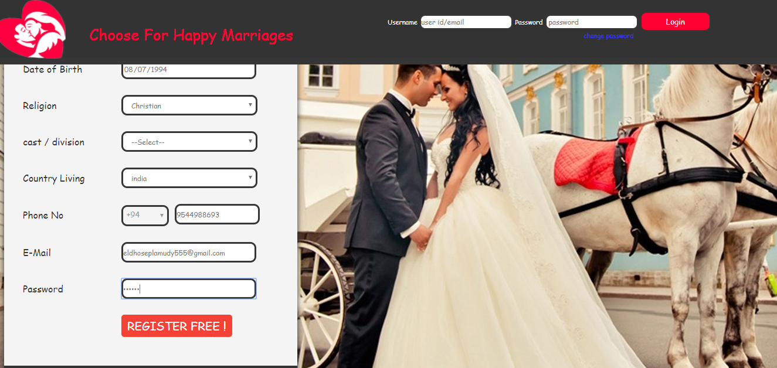

**User Registration page2**

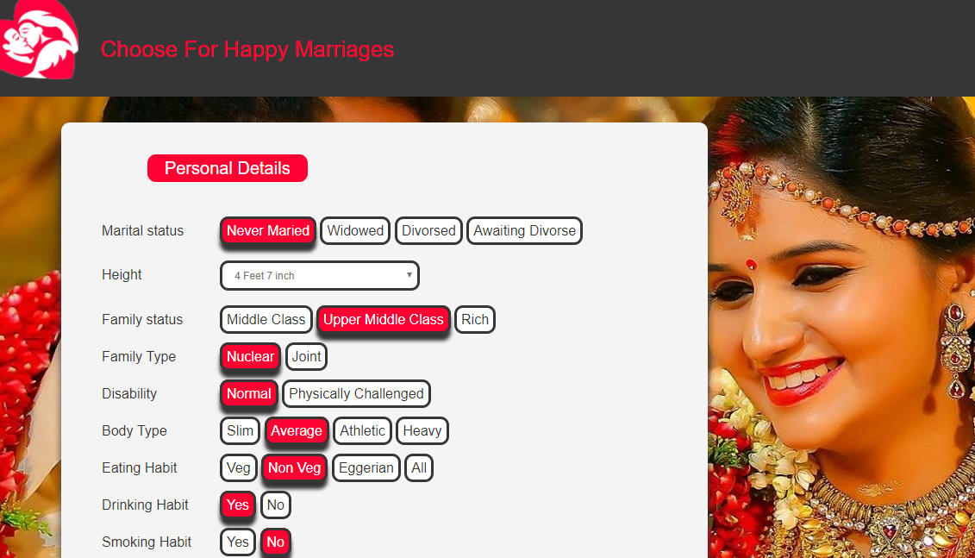

**Final Registration**

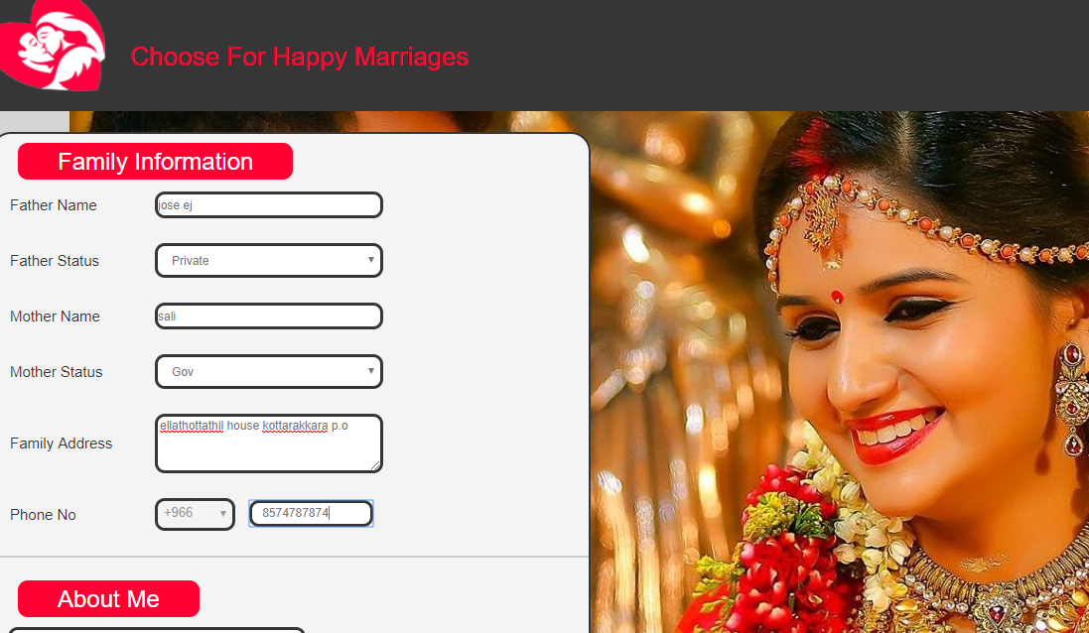

**User Home**

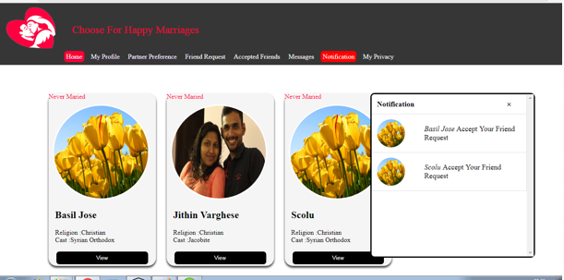

**Region Preference**

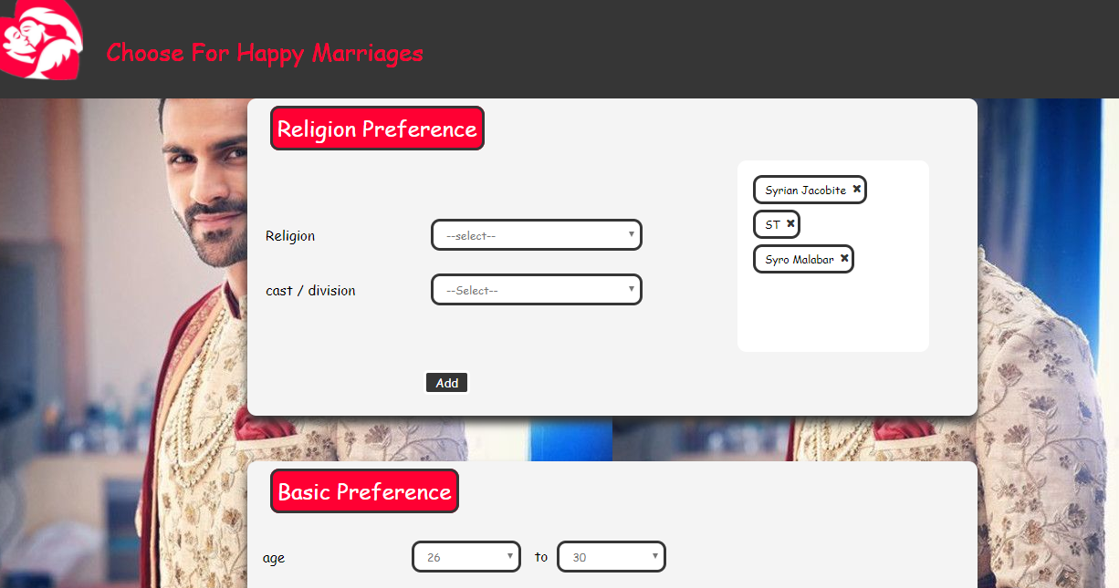

**View of gallery**

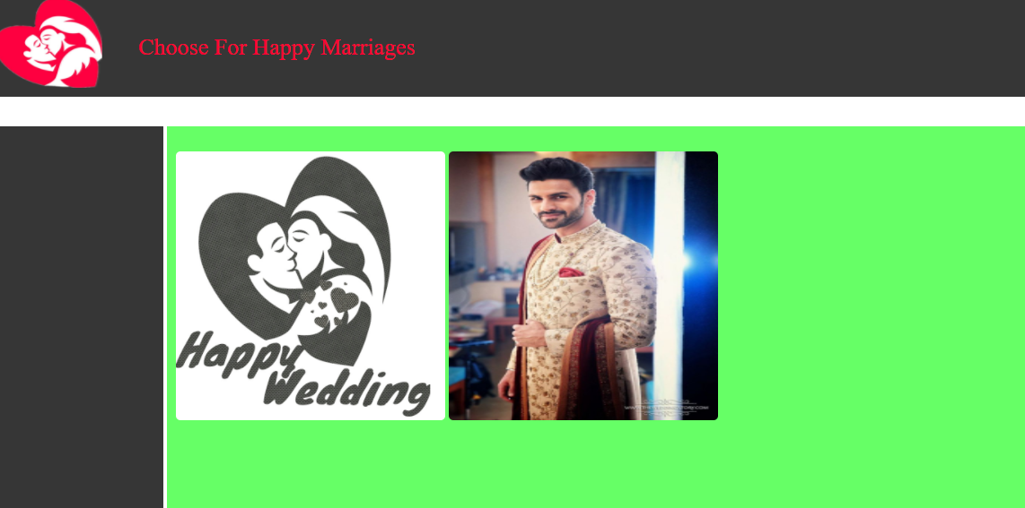

**Marital Status Entry**

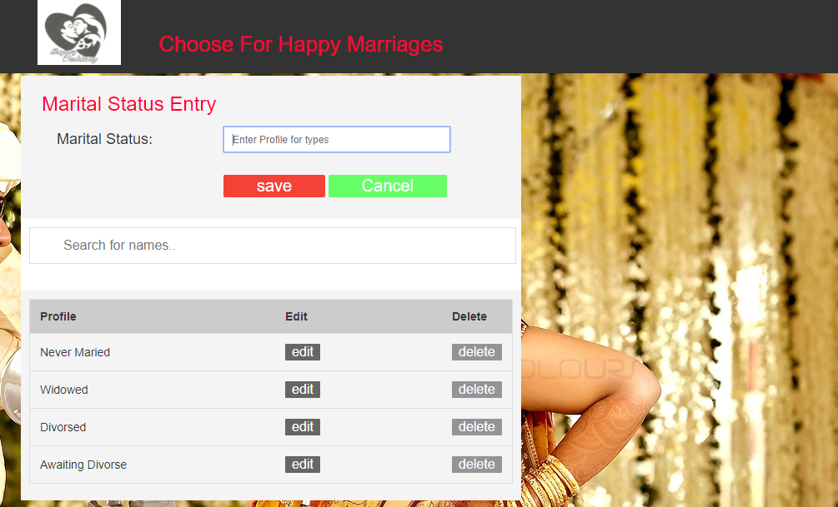

**10.3 APPENDIX C**

**10.3.1 Bibliography**

* + - * [www.support.mircosoft.com](http://www.support.mircosoft.com)
      * [www.developer.com](http://www.developer.com)
      * [www.w3Schools.com](http://www.w3Schools.com)
      * [www.msdn.microsoft.com](http://www.msdn.microsoft.com)
      * [www.msdn.microsoft.com/net/quickstart/aspplus/default.com](http://www.msdn.microsoft.com/net/quickstart/aspplus/default.com)
      * [www.fmexpense.com/quickstart/aspplus/default.com](http://www.fmexpense.com/quickstart/aspplus/default.com)
      * [www.asptoday.com](http://www.asptoday.com)
      * [www.aspfree.com](http://www.aspfree.com)